Lesson Plans: 1/19/17 and 1/20/17
All students must take the “Renaissance STAR 360” assessment. This is a mandatory district evaluation of students’ progress at this point in the year. Students have taken this assessment before, and should have no problem taking this online evaluation again.

If there are any questions or problems, though, please contact Herman Seufert. His email address is hjseufer@episd.org, and his office is Room 155.

STUDENT INSTRUCTIONS:
Students will go to https://star360.episd.org/ .
Students will log in as they usually do for almost all school-related laptop functions:
- Students will use their EPISD email stem as their username.
Example: If the EPISD email is djyost1234@episd.org, the email stem would be djyost1234 .
- Students will log in using their birthdate (YYYYMMDD) as their password.
Example: If the birthday is November 10, 1984, so the password would be 19841110 .
Students will take click on the “Take a Reading Test” assessment and choose the “Desiree Yost” option as the correlating teacher for this test.
- REMEMBER: THE ASSESSMENT IS TIMED!
- Students cannot have any other windows open.
- Students cannot listen to music during this time.
- Students cannot use a dictionary.

When students are done with the assessment, they can quietly listen to music and work on any other assignments they may have for my class or other classes.

If students do not have a laptop, they can try using their phone. If that doesn’t work, the student must complete the following essay and turn it in by the end of class:

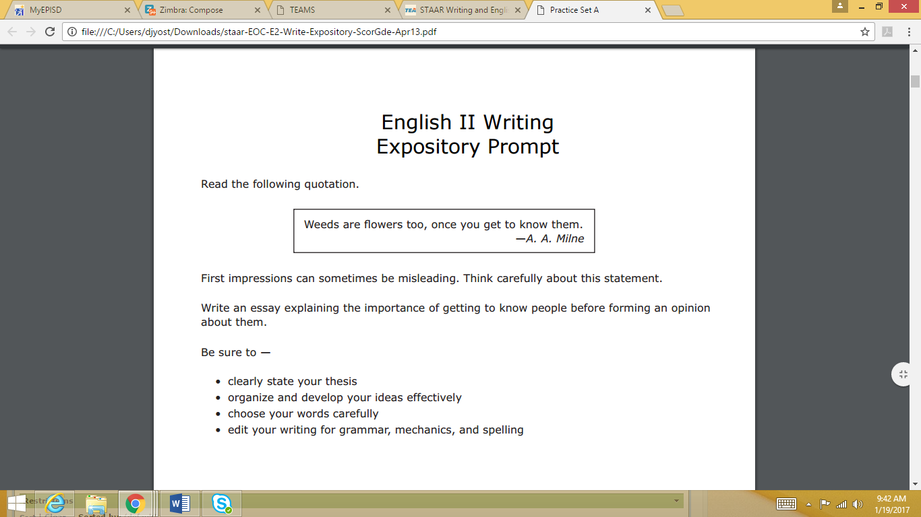

A dictionary CAN be used for this assignment.
This essay is only for students who are unable to take the STAR360 Reading Assessment today.

Thank you!

DY

